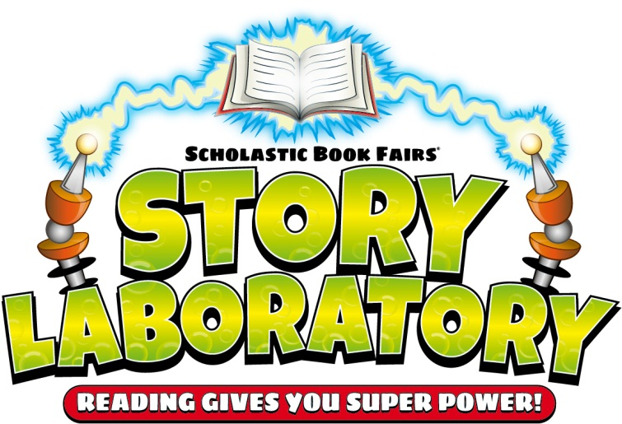

*Permission to reproduce this item is granted by Scholastic Book Fairs*

© 2013 Scholastic Inc. 10425 • 81504

Dear Parents

We are holding a book fair in the library as part of Education Week.

Books are of the same quality as those found in the book club brochures.

* Erasers and pencils start at $1
* Posters $2 sml $4 lge
* Books range from $5 - $30

Varieties include:

Colouring and activity books

Picture books

First Chapter

Fiction books

Non- Fiction books

Joke books

“Wacky Specials” ($6 each, can’t be reordered)

* Students from year 1-6 will be making a wish list during the week with books they would like to buy. If you cannot attend on either of the buying days you are able to send money in an envelope for your child to buy books/posters/pencils etc.
* Students will be purchasing on Thursday 1st August. Only students with money will be sent up by teachers to purchase the books.
* The majority of books can be re-ordered if they sell out. In this case the book is paid for on the day and delived within a few weeks of the fair.

**Viewing times for Parents**

8am – 10am Wednesday 31st July

**Buying times for Parents**

8am – 4pm Thursday 1st August

8am – 11am Friday 2nd August

Ms Adams

Teacher Librarian